## ***Team***

Farida Elhussainy

221001958

Yassin hamad

221000948

Yassin elgendy

221002249

Shahd amr

221001747

## Section 1 :Clinic System

***Intro:***

Clinic administration is more important than ever in the quickly changing healthcare sector of today. Managing patient data, appointment scheduling, medical records, invoicing, and resource allocation are all becoming more difficult for clinics, which are the foundation of basic healthcare delivery. Outdated or manual processes can result in mistakes, inefficiencies, and less than ideal patient care. The goal of this project is to create a Clinic Management System (CMS), a cutting-edge, efficient software program designed to satisfy the requirements of medical professionals and their clients.

***The Problem:***

1- Manual Data Entry: Clinics often store patient data manually, either in paper records or fragmented digital systems, which can lead to human error, data loss, or delays in accessing important medical information.

2- Appointment Scheduling Conflicts: Patients or doctors sometimes experience difficulties with scheduling, leading to missed appointments, double-bookings, or inefficient time management.

3- Treatment Documentation: Oftentimes, the process of recording treatment plans—including diagnostic imaging like X-rays—is fragmented and unrelated to the patient's medical background.

4- Billing and Financial Management: Manual billing systems can result in inaccuracies, delays in payment collection, and inconsistent pricing for similar procedures.

5- Security and Privacy Concerns: Patient data is highly sensitive, and the lack of adequate security measures can lead to unauthorized access or breaches of confidentiality.

**User Personals:**

1. **Doctor**:
   * Needs real-time access to patient records.
   * Requires tools for appointment management and case history tracking.
2. **Patient**:
   * Wants easy access to appointment booking, test results, and prescriptions.
3. **Clinic Admin**:
   * Needs to manage appointments, billing, and staff schedules efficiently.

***Proposed Solution:***

A Comprehensive Web-Based Clinic System App

A web application for a clinic system that incorporates patient administration, appointment scheduling, treatment recording, and financial transactions will be developed by us. In addition to improving patient care and clinic efficiency, this technology will facilitate smooth communication between patients, physicians, and administrative personnel.   
Any internet-connected device will be able to access the program, making it simple for users to navigate and effectively manage a variety of tasks.

**Section 2 :**

**Functional Requirements**:

**1. Patient Management:**

- Functionality: Comprehensive patient data, including ID, name, age, insurance information, and dental history, will be recorded and stored by the system. Additionally, it will keep note of previous allergies, prescriptions, and treatments.

- Benefits: This digitized information enables faster access to patient records, reduces the risk of errors, and improves the overall patient experience.

**2. Appointment Scheduling:**

- Functionality: A scheduling module that allows patients to book appointments online, view available slots, and schedule with specific doctors. The system could send automated reminders to patients and doctors, reducing no-shows and late arrivals.

- Benefits: Improves clinic time management, enhances patient convenience, and reduces appointment conflicts.

**3. Clinical Features:**

- Functionality: A dashboard where doctors can record treatment plans, procedures, and access detailed diagnostic images such as X-rays. Doctors can upload images, write notes, and track progress for each patient.

- Benefits: Ensures a complete and organized record of the patient's treatment plan and history, facilitating accurate decision-making and continuity of care.

**5. Analytics and Reporting:**

- Functionality: Analytics capabilities to provide reports on financial performance, appointment patterns, treatment types, and patient demographics; these insights can help with decision-making and enhance clinic operations.

- Benefits: Helps in strategic planning, improving patient care, and optimizing resources.

**Section 3 :  
Non-Functional Requirements**:

**1. Security:**

- Functionality: To protect patient information from unauthorized access. Only authorized personnel can view or edit sensitive data.

- Benefits: Ensures patient privacy, complies with regulations such as HIPAA, and reduces the risk of data breaches.

This web application will serve as an all-in-one solution for clinic management, offering efficient tools to handle patient information, appointments, financials, communication, and security. The system will not only improve the operational efficiency of the clinic but also provide a better, more organized experience for both patients and staff. This innovative solution will ensure that dental clinics can deliver high-quality care while maintaining secure and accurate data management.

**2-Performance :** like Response Time, Scalability, Data Retrieval Speed

3- **Security**

3.1 Authentication:

Only authorized users can log in and access sensitive data.

3.2 Data Encryption:

All data transmitted between the client and server must use HTTPS with TLS encryption.

3.3 Access Control:

Role-based access ensures that only authorized personnel can access sensitive features, such as patient records.

**4-Reliability**

4.1 Availability:

The system must have 99.9% uptime to ensure continuous access for users.

4.2 Error Handling:

The system must gracefully handle errors and provide meaningful error messages to users.

4.3 Backup and Recovery:

Regular backups of patient and appointment data with recovery time objectives of under 30 minutes.

**5. Maintainability**

5.1 Code Modularity:

Code must follow best practices for modularity to make maintenance and upgrades easier.

5.2 Documentation:

Provide comprehensive documentation for developers and system administrators.

5.3 Version Control:

All code changes must be tracked using a version control system like Git.

**6- Audit and Monitoring:**

6.1 Logging:

Track all user activities (e.g., logins, data modifications) for audit purposes.

6.2 Monitoring:

Implement performance monitoring and alerts for server health and uptime.

**Tools and Technology:**

* [HTML94.3%](https://github.com/faridaelhussainy/SW-Project/search?l=html)
* [CSS4.3%](https://github.com/faridaelhussainy/SW-Project/search?l=css)
* [JavaScript1.4%](https://github.com/faridaelhussainy/SW-Project/search?l=javascript)

## Section 4: Key Features

Starting by the idea of building A web application.

Explaining the functionalities that could be Offered in our Dental Clinic system.

**Patient Management:** Recording Patient past Treatments digitally, and recording patient information (ID, Name, Age, insurance), Storing more detailed information about the patient regarding dental care, dental history,

**Appointment Scheduling:** A system for patients and doctors to set appointments for more flexibility, possibly reminder for doctors.

**Clinical Features:** For doctor to record patient treatment plan, procedures, display X-ray imaging.

**Financial management:** Billing, estimated cost for patient treatment.

**Management:** Managing staff schedules, tasks and performance, Analytics reports on performance and patient demographics, and inventory management.

**Communication:** Messaging, Reminders, and document sharing.

**Security:** protecting patient data for unauthorized access, Access management.

Section 5 :

Diagrams:

## Class Diagram

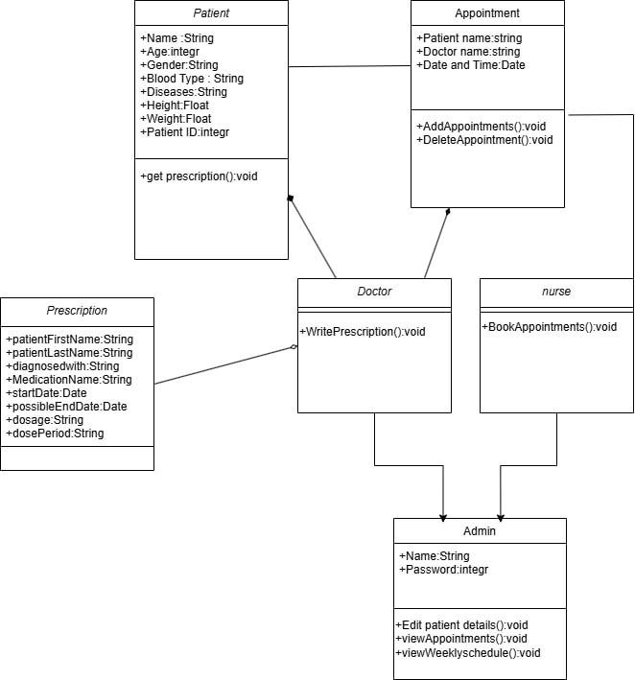

## Use Case Diagram

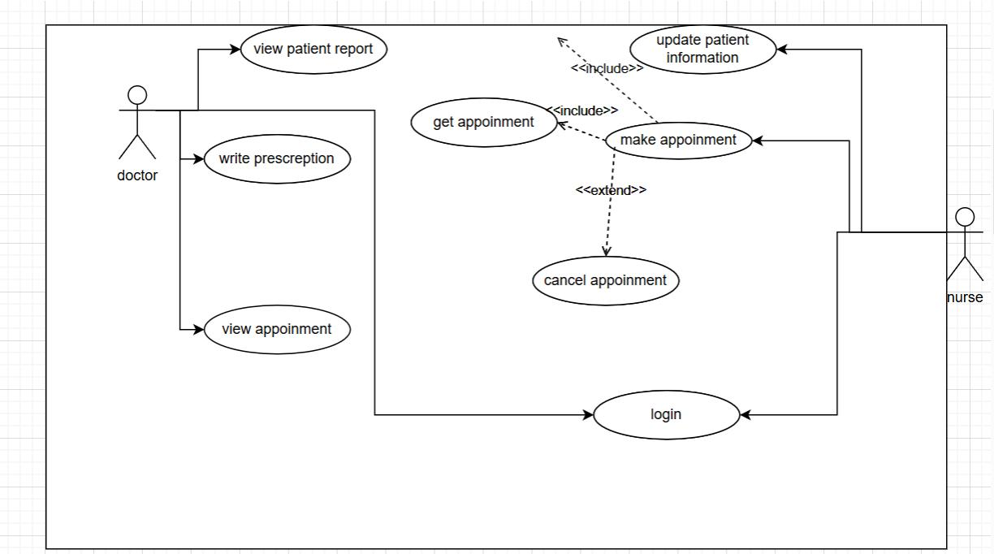

## Sequence diagram

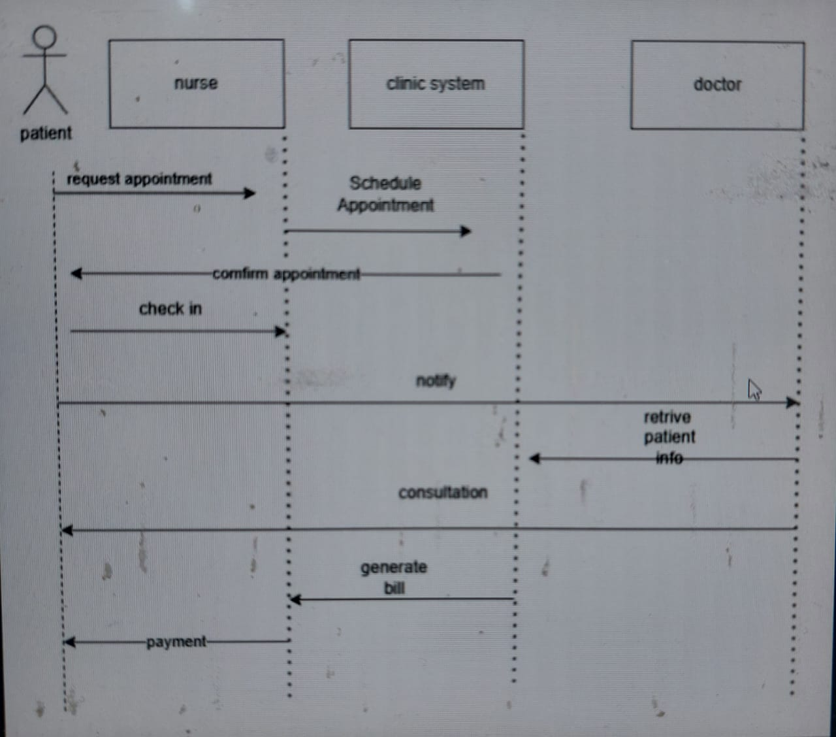

## Section 6:

## Screenshots of the frontend

